Project Proposal on

Book reading system

Ninjeng lama

00175018

Computing Project

Level 5 Diploma in Computing

Softwarica College of IT & E-Commerce

Kathmandu, Nepal

9 April 2019

Summitted to: NIMAN MAHARJAN

Table of Contents

Chapter 1 3

1.1 Project introduction 3

1.2 Problem definition 3

Chapter 2 4

2.1 Scope 4

2.2 Aims 4

2.3 objectives 4

2.4 Development methods 5

2.5 Design pattern 6

Chapter 3 7

3.1 Project plan 7

3.2 Work Breakdown Structure (WBS) and Time Estimate 7

3.3 Showing the Work Breakdown structure in tabular form. 8

3.4 Milestones 9

3.5 Schedule 11

Chapter 4 13

4.1 Risk management 13

Chapter 5 14

5.1 Configuration management 14

Conclusion 16

References 17

# Chapter 1

## 1.1 Project introduction

The time is changing as we speak and as well as the technology. The people are getting modern day by day. The people can share every single detail to a certain person who is in the other side of the world. The development of technology is also affecting the modern education process, In the modern education process people don’t only read form text book or go to library for research they can read/research from the mobile, iPad and different other devices through internet. Similarly, I am developing a project named “**Book reading system”** which help the user to read book at any places as they please.

It is an electronic version of tradition printed book that can be read by using smart phones. The project is a type of eBook application software like Kindle, calibre etc. The concept of eBook software was invented by a woman in Spain named Angelia rules robles who was a school teacher. The idea of her was that the student would not have to carry large books while coming to school and make their life easier. Since she had the idea in 1949 AD. That time period did not have any electrical devices so her project was rejected by the nature. But the current time is ruled by computer/ smart phones so the project is effective in the current time. The programming language I will be using to develop the application will be Java because it is the most popular language for developing mobile application.

## 1.2 Problem definition

Many problems are encountered using traditional books some of the problem that I am trying to solve by making the Book reading system are:

1. **Voice reader**: Using voice reader the software it self-read the content present in the screen. By voice reader books can be listen in public areas. It helps the user to save time.
2. **Font adjustment**: When your eyes fell strained u can change the font size colour of the font using Book reading system whereas in the regular book u just have no choice but to stop reading.
3. **Travel**: By using traditional books traveling might be a problem whereas using Book reading system it makes it easy to travel with any document or book we want.
4. **Storage**: if we collect 1000 traditional book than it may consume about 2-3 rooms in a mismanaged way but using Book reading system the database can store 1000 books in just 1-2 GB of storage.

The system will over come the problem and give efficient result which will help the user in their daily life.

# Chapter 2

## 2.1 Scope

. The main features of the Book reading system are:

1. Voice reader.
2. Font adjustment.
3. Personal account.
4. Personal Library system.
5. Downloading Book PDF for Offline use.
6. Add books etc.

The explanation of the software is shown below:

1. A user can create an account for the application by filling his/ her details like Name, password, age etc by opening create user form.
2. A user can login after creating an account and also can delete the account if he/she don’t want it.
3. After login the user have multiple choices like add books, read book online, download PDF of books for offline.
4. While reading the user can user voice reader where the system the content present in the screen.

## 2.2 Aims

If a person doesn’t have his/ her aims in life then they will be clueless for their future. The same theory applies in software development also. If the software doesn’t have aim than making the software is waste of time. The main Aims to develop the Book reading system are shown below:

1. To make it portable so that user fells no burden.
2. To make it more environmentally friendly than Print books/ Physical books.
3. To make it easy for the reader so that they don’t even need to go out of the house to borrow books from local libraries.

## 2.3 objectives

The main objective to develop the Book reading system are given below:

1. To develop an electrical reading system so that user can read them any time and places they please.
2. To learn Java a new programming language so I could increase my knowledge.
3. To test if I could learn a new language and create a software with that language within 3 months.
4. To develop my designing, analysis skills.

## 2.4 Development methods

The development method I will use to develop the Book reading system is water fall method because the waterfall method emphasizes a logical progression of steps. Since, the project will be developed by a single person using agile, OOAD method will be hard to catch up with because those methodology are best in use if there is a team or group of members to develop an application. The waterfall model is easy to understand and as I told before it contains phase and each phase must be complete to start another phase which will help me to track how much the application has been develop. The Phase of the water fall model are:

1. Requirement analysis.
2. Design
3. Implementation
4. Testing
5. Maintenance

Showing the waterfall model in diagram.

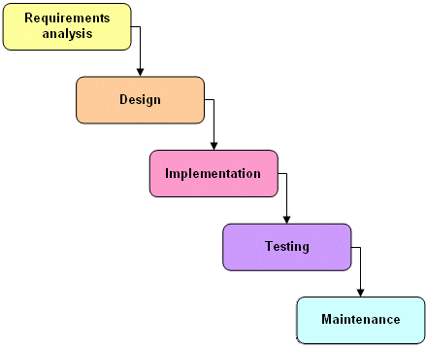

Firstly, I will collect all the requirements need to develop the application such as what features are needed and what are the strength of the application and so on. Then I will design the application layout, user interface etc for the system. After the designing phase is done the implementation or the code writing will be started.

After the Implementation phase is done the testing of the application will be held where I will test if the application is running according as the command. In the maintenance phase if any bug or errors are found in the future use than it will be maintained and updating the system also falls on the maintenance phase.

## 2.5 Design pattern

I will be using MVC design pattern for this project. MVC Pattern stands for Model-View-Controller Pattern. This pattern is used to separate application's concerns.

* **Model** - Model represents an object or JAVA carrying data. It can also have logic to update controller if its data changes.
* **View** - View represents the visualization of the data that model contains.
* **Controller** - Controller acts on both model and view. It controls the data flow into model object and updates the view whenever data changes. It keeps view and model separate.

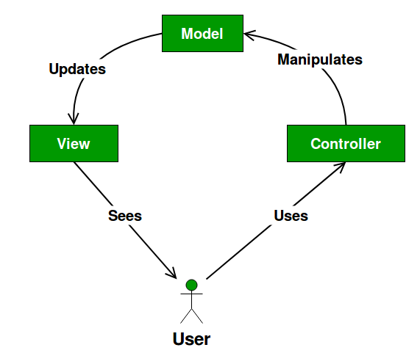

The benefits of using MVC design pattern in book reading system is that, it helps the development process to go faster since the project deadline is with 3 months. It offers the multiples view by which user interface can be changed frequently. The modification never affects the entire model. So I think the best design pattern for Book reading system is the MVC pattern.

# Chapter 3

## 3.1 Project plan

In this section I will be showing the plan for the project, how the work will flow while developing the project. The tools/software that will be used while developing the project are: Star UML (UML diagrams), Android studio (Development), SQLite (Database), Ms Word (Report) etc.

## 3.2 Work Breakdown Structure (WBS) and Time Estimate

A work breakdown structure is a key project deliverable which breakdown the project into small manageable section. The purpose of using Wok breakdown structure is to manage the project and make the work efficient. Since every project relies on the limited time given to develop the project the WBS mange the Limited time and make this planning consistent and provides effective project execution. (Chron, n.d.)

## 3.3 Showing the Work Breakdown structure in tabular form.

|  |  |  |
| --- | --- | --- |
| **WBS** | **TASK NAME** | **NUM OF DAYS** |
| **0** | **Book reading system** | **83** |
| **1** | **PROJECT PROPOSAL** | **9** |
| **2**  2.1  2.2  2.3  2.4 | **Requirement analysis**  Requirement gathering  Use case diagram  Class diagram  Activity diagram | **18**  6  4  4  4 |
| **3**  3.1  3.2  3.3  3.4 | **DESIGN**  User interface  Database creation  Structural diagram  Behavioural diagram | **18**  5  4  4  5 |
| **4**  4.1  4.2 | **IMPLEMENTATION**  Coding  Database creation | **26**  17  9 |
| **5**  5.1  5.2  5.3 | **TESTING**  Unit Testing  Black Box Testing  White Box Testing | **18**  6  6  6 |
| **6**  6.1  6.2 | **Reporting**  Final Report  Slides | **12**  7  5 |

## 3.4 Milestones

Setting the Milestone for the Project.

|  |  |  |
| --- | --- | --- |
| **TITLE** | **START DATE** | **END DATE** |
| 1. **Proposal** | **1st April 2019** | **9th April 2019** |
| 1. **Requirement Analysis** | **10th April 2019** | **27th April 2019** |
| 2.1 Requirement gathering | 10th April 2019 | 15th April 2019 |
| 2.2 Use case diagram | 16th April 2019 | 19th April 2019 |
| 2.3 Class diagram | 20th April 2019 | 23rd April 2019 |
| 2.4 Activity diagram | 24th April 2019 | 27th April 2019 |
| 1. **Design** | **28th April 2019** | **15th May 2019** |
| 3.1 User interface | 28th April 2019 | 5th May 2019 |
| 3.2 Database design | 3rd May 2019 | 6th May 2019 |
| 3.3 Structural model | 7th May 2019 | 10th May 2019 |
| 3.4 Behavioural model | 11th May 2019 | 15th May 2019 |
| 1. **Implementation** | **16th May 2019** | **10th June 2019** |
| 4.1 Database build | 16th May 2019 | 24th May 2019 |
| 4.2 Coding | 25th May 2019 | 10th June 2019 |
| 1. **Testing** | **11th June 2019** | **28th June 2019** |
| 5.1 Unit Testing | 11th June 2019 | 16th June 2019 |
|  |  |  |
| 5.2 White Box Testing | 17th June 2019 | 22nd June 2019 |
| 5.3 Black Box Testing | 23rd June 2019 | 28th June 2019 |
| 1. **Final Documentation** | **29th June 2019** | **10th July 2019** |
| 6.1 Final report | 29th June 2019 | 5th July 2019 |
| 6.2 Slides | 6th July 2019 | 10th July 2019 |

**Requirement analysis**: The requirement analysis is separated into 4 steps the requirement gathering where I have given 6 days of time so that I will could collect all the requirement needed for the development of Book reading system. After the requirement I collect I will create a use case diagram which will show the features that will be applied in the system to make the use case diagram I have gave time about 4 days so all the features may be added. Similarly, the requirement gathering will help me to create class and activity diagram of the system which I have separated 4days, 4days respectively.

**Design**: designing is also one of the time-consuming process so in this project I have separated the designing process into 4 steps. Firstly, I will create the user interface where user can create account so to create that I have give time of 5 days, for database creation I have given time of 4 days so no errors will hamper in the future. I have separated 7 and 14 days respectively for Structural model and Behavioural model.

**Implementation**: This is the phase where all the logical implementation or the coding is done. I have separated the phase into 2 different steps. One is the Database build where I will build all the necessary data storage needed for the application, I have separated 9 days for the step and secondly the coding steps where I will make the system to work as the system must be needed. The days I have separated for the steps are 17 days.

**Testing**: It is a phase where test is done to the application. To check if the result is accurate or not or if there are any bugs. For the Book reading system, I will be doing 3 steps they are Unit testing, White box testing and Black box testing. For the testing I have separated 6 days, 6 days, 6 days respectively.

**Reporting**: In this phase the reporting of the project is done. This phase is also divided into 2 steps Final report and slides. Where Final report is done in 7 days and Slides are done in 5 days for presentation.

## 3.5 Schedule

A chart in which a series of horizontal lines shows the amount of work done or production completed in certain periods of time in relation to the amount planned for those periods is known as Gannt chart. The Gannt chart for developing the Book reading system is shown below:

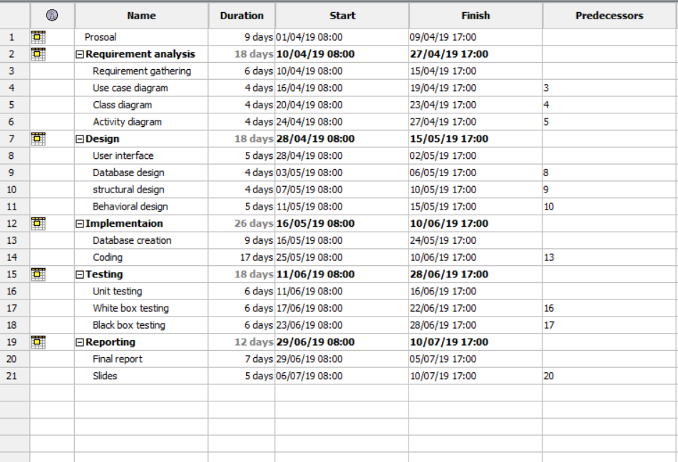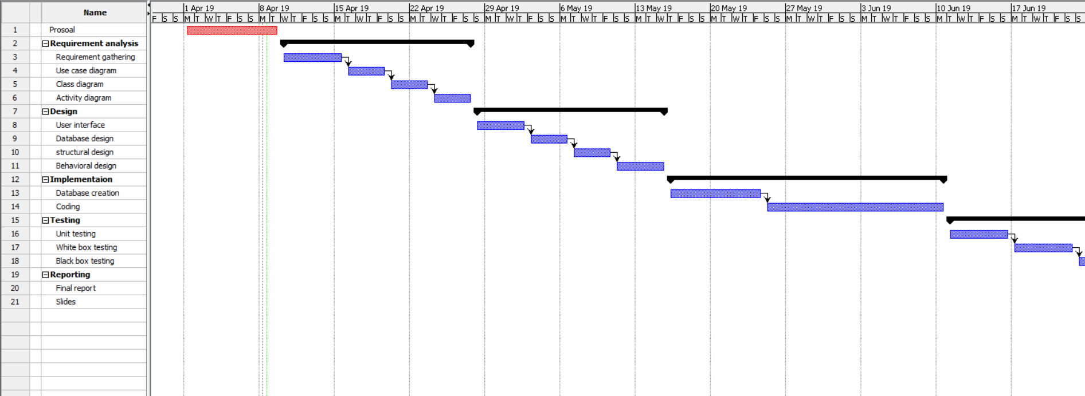

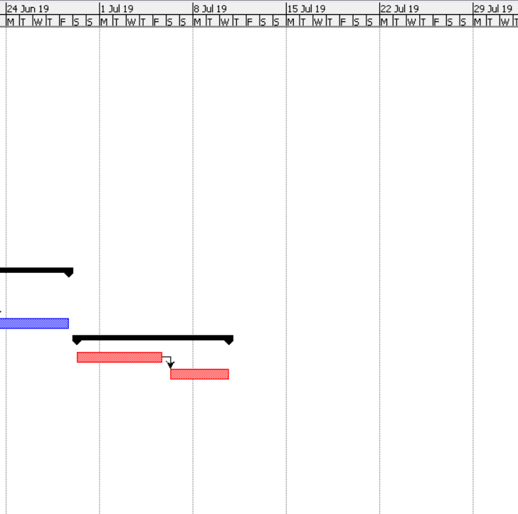

# Chapter 4

## 4.1 Risk management

Project risk management is the process of identifying, analysing and then responding to any risk that arises over the life cycle of a project to help the project remain on track and meet its goal. Risk management isn’t reactive only; it should be part of the planning process to figure out risk that might happen in the project and how to control that risk if it in fact occurs.

To estimate the impact of each identified risk we use

Impact = Livelihood x Consequences

Livelihood table

|  |  |
| --- | --- |
| Livelihood | Value |
| Low | 1 |
| Medium | 2 |
| High | 3 |

Consequences table

|  |  |
| --- | --- |
| Consequences | Value |
| Very low | 1 |
| Low | 2 |
| Medium | 3 |
| High | 4 |
| Very high | 5 |

|  |  |  |  |  |
| --- | --- | --- | --- | --- |
| Risk | Livelihood | Consequences | Impact | Action |
| Nature disaster | 3 | 1 | 3 | Back up plan. |
| Server failure | 2 | 4 | 8 | Updating the server frequently. |
| Hacking | 2 | 3 | 6 | Making the server secure to overcome hackers. |
| Database crash | 2 | 4 | 8 | Distributed database system must be applied. |
| Unauthorized access | 2 | 3 | 6 | Making the login system and database more secure. |
| Hardware failure | 3 | 2 | 6 | Restarting the hardware. New hardware system. |
| Client does not what they want | 2 | 3 | 6 | The developer must spend time consoling the client what they want. |

# Chapter 5

## 5.1 Configuration management

Software configuration management (SCM) is a software engineering discipline consisting of standard processes and techniques often used by organizations to manage the changes introduced to its software products. SCM helps in identifying individual elements and configurations, tracking changes, and version selection, control, and baselining (techopedia, n.d.). The configuration of the book reading system is shown in the following figure using Command prompt.

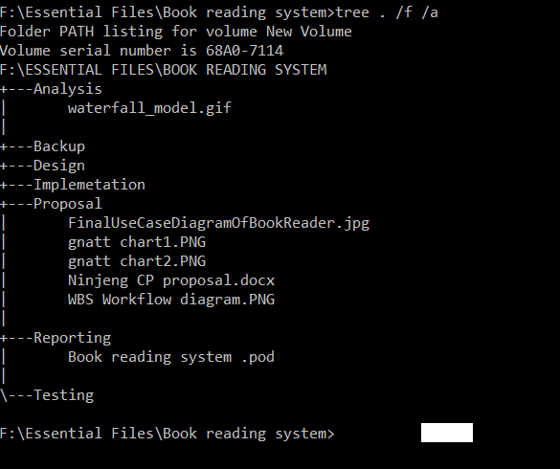

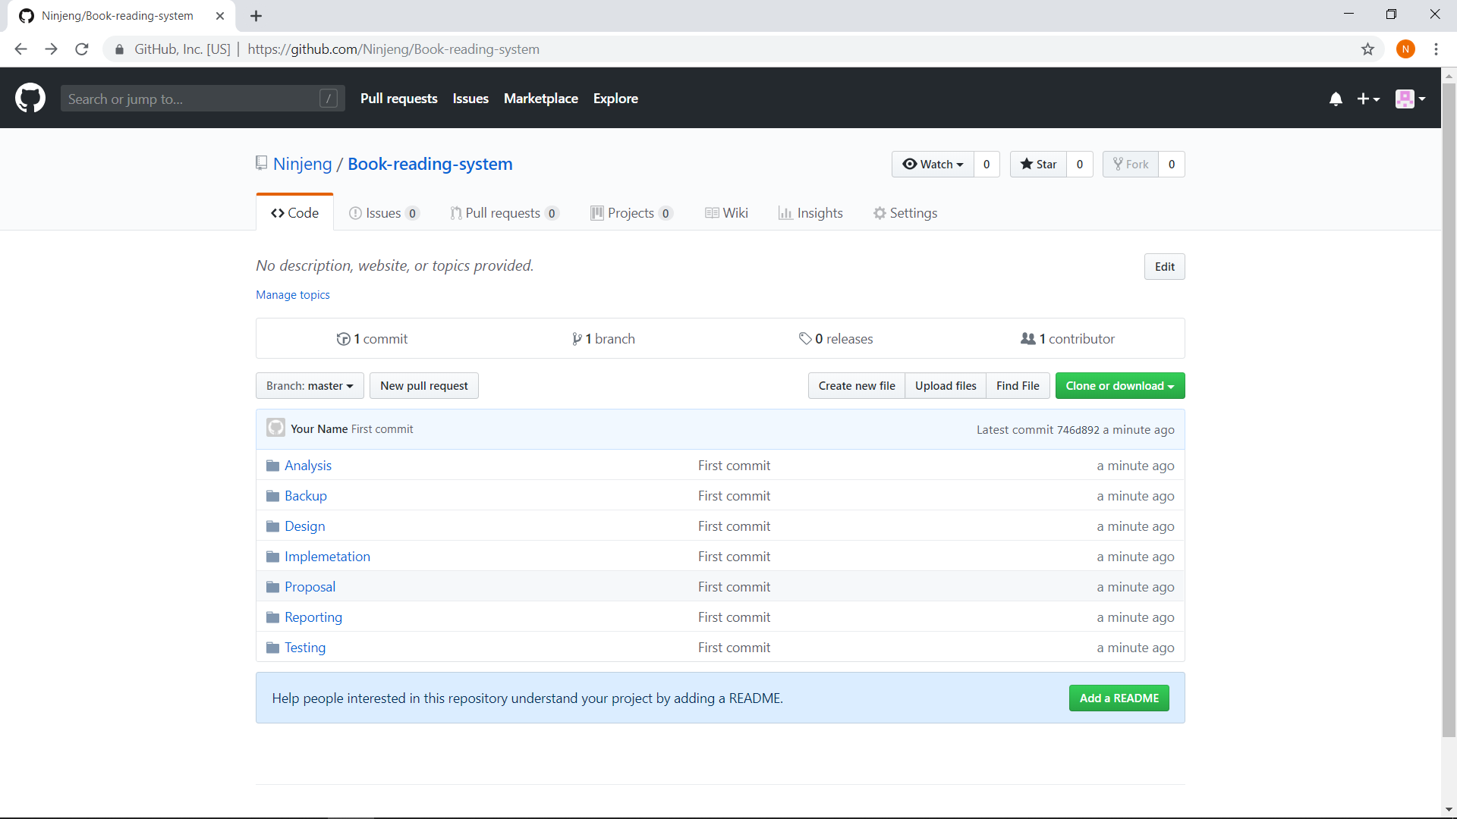

GitHub link: <https://github.com/Ninjeng/Book-reading-system>

# Conclusion

Book reading system is an electrical version of traditional printed books. It is an environmentally friendly system which helps the user to read book at any place and time they please. The software allows the user to read published books and also publish book of their own. The implementing of the system will reduce time consuming of going to store/ library for burrowing books. It will be more portable than regular books.

# References

(n.d.). Retrieved from techopedia: https://www.techopedia.com/definition/24583/software-configuration-management-scm

(n.d.). Retrieved from Chron: https://smallbusiness.chron.com/importance-work-breakdown-structure-54294.html